Lab - My Local Network

# Objectives

* Record all the different network attached devices in your home or classroom.
* Investigate how each device connects to the network to send and receive information.
* Create a diagram showing the topology of your network.
* Label each device with its function within the network.

# Background / Scenario

The path that a message takes from its source to destination can be as simple as a single cable connecting one computer to another or as complex as a network that literally spans the globe. The network infrastructure contains three categories of hardware components:

* End devices
* Intermediary network devices
* Network media

# Instructions

Take a close look at the network you have at home or school. Record the network and end-user devices that are connected on the local network.

Sample

| Manufacturer | Device | Location | Connection | Media |
| --- | --- | --- | --- | --- |
| Apple | iPhone | Mobile | Wireless | WiFi & cell phone |
| Samsung | Galaxy Smart Phone | Mobile | Wireless | WiFi & cell phone |
| Cisco | Cable Modem | Home office | Wired | Cable TV coaxial cable and Ethernet cable. |
| Linksys | Wireless Router | Home office | Wired | Ethernet cable. |
| HP | Printer/Scanner | Home office | Wireless | WiFi |
| Apple | MacBook Air | Mikayla’s Room | Wireless | WiFi |
| Beats by Dre | Headphones | My Room | Wireless | Bluetooth |
| Microsoft | Xbox | My Room | Wired | Ethernet Cable |

Your Local Network

| Manufacturer | Device | Location | Connection | Media |
| --- | --- | --- | --- | --- |
| Hamilton Beach | Coffee Maker | Kitchen | Wireless | WiFi |
| HP | Printer/Scanner | Living Room | Wireless | WiFi |
| Philllips | Smart Light Bulb x 10 | Throughout the house | Wireless | WIFI |
| HP | Laptop | Apartment | Wireless | WIFI |
| Fios | Wireless Router | Living Room | Wired | Ethernet Cable |
| Amazon | Alexa Echo Show | Kitchen | Wireless | WIFI, Bluetooth |
| Samsung | TV | Living Room | Wired | Ethernet Cable |
| Apple | Iphone | Apartment | Wireless | Cellular, WIFI, Bluetooth |

Continue the list on a separate page if necessary.

## Reflection

* 1. Are there other electronic devices that are not connected to the local network to share information or resources? What would be the benefit of having these devices online?Type your answers here.

**I have Air diffusers in every room. They do not connect to the local network however if I were to buy the “Smart Diffusers” I wouldn’t have to get up to turn them on. I could bask in my laziness.**

* 1. Which type of connectivity is used most frequently in your local network, wired or wireless?

**Wireless**

Type your answers here.

* 1. Draw a diagram of your local network. Label each device with a name and location.

Draw your diagram here.

# Answer Key

Your Local Network

| Manufacturer | Device | Location | Connection | Media |
| --- | --- | --- | --- | --- |
| Motorola | Cable Modem | Home Office | Wired | Cable TV coaxial cable and Ethernet cable. |
| Netgear | Wireless Router | Home Office | Wired | Ethernet Cable |
| HP | All-in-One Printer | Home Office | Wireless | WiFi |
| Dremel | 3D Printer | Home Office | Wired | Ethernet Cable |
| Lenovo | Laptop | Home Office | Wireless/Wired | WiFi/Ethernet Cable |
| Apple | Laptop | Home Office | Wireless/Wired | WiFi/Ethernet Cable |
| Samsung | Smart TV | Great Room | Wireless | WiFi |
| Apple | iPhone | Mobile | Wireless | WiFi & cell phone |

## Reflection

* 1. Are there other electronic devices that are not connected to the local network to share information or resources? What would be the benefit of having these devices online?

Network Attached Storage can provide extra local or back up storage and allow users to share their files in a central location. Home Security cameras can be connected to the network so you can have access to the information remotely.

* 1. Which type of connectivity is used most frequently in your local network, wired or wireless?

If most of your devices are connected via Ethernet cables, then you would be using wired connection more frequently. However, if most of your devices are more mobile, such as tablets, smartphones, laptops, you probably use the wireless connection more often.

* 1. Draw a diagram of your local network. Label each device with a name and location.

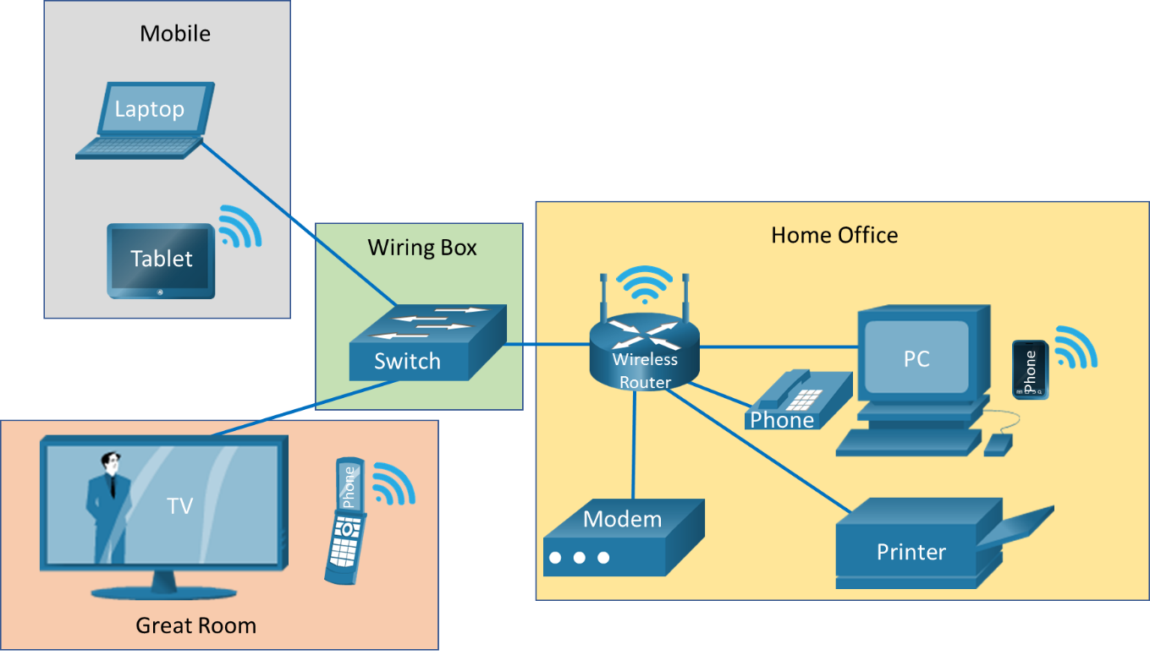

End of document